

**Manual:**

**For the ADAPNER Biogas game**

**Author:**

Frank Pieriea,b

a Hanze University of applied sciences – Centre of Expertise - Energy, Zernikelaan 17, 9747 AA Groningen, The Netherlands.

b University of Groningen - Centre for Energy and Environmental Sciences, Nijenborgh 6, 9747 AG Groningen, The Netherlands.

Contact: Frank Pierie Researcher/Lecturer | Hanze University of Applied Sciences | Hanze Research Centre - Energy |   
Visiting address: Nijenborgh 6, 9747 AG Groningen|T:  +31 (0)50 595 4640 |M:  +31 (0)6 510 67 674 |  
 E:  [f.pierie@pl.hanze.nl](mailto:f.pierie@pl.hanze.nl) | W:  [www.hanzegroningen.eu](http://www.hanzegroningen.eu/) /   <http://www.en-tran-ce.org/>

**Project:**

ADAPNER (Adaptive Logistics in Circular Economy, NWO 438-15-519)

**Version Manual:**

2020-06-17



## Content

1. Introduction - 2 -

2. The goal of the game - 3 -

3. The roles in the game - 3 -

4. The playing map - 4 -

5. The biogas production pathway - 5 -

6. The biomass cards - 5 -

7. Playing biomass cards - 6 -

# Introduction

We stand on the brink of an important transition towards an energy system capable of fulfilling our energy needs renewable and sustainable for the coming future. Therefore, renewable energy sources such as wind, solar, and biomass must be adapted and integrated in society, which will have a substantial effect on our surroundings. The importance of renewable integration in society cannot and must not be underestimated and, therefore, communication with the important actors involved regarding the potential benefits and drawbacks, but also the potential impacts on the landscape is adamant. Therefore, within the Adapner project a specific communication tool is developed in the shape of a serious game, communicating important result elements of the Adapner project in a new innovative way.

The ADAPNER biogas game is the We-Energy game with a twist where a biogas scenario for the village of “Adapner” can be devised providing all the required energy solely using biomass and the Anaerobic Digestion process. During this quest there will be decision to make and hurdles to overcome. You as a representative in the council of the village of Adapner must decide to go green, or cheap, or to have energy all the time every time, or maybe even all of them. Also, after the production of biogas you are left with a waste product called digestate. This must also be handled with care as not always all the digestate can be used locally as green fertilizer. But whatever you do, you must keep the other stakeholders and actors in your council happy as there is only success together. Therefore, your mission if you choose to accept, is to make the village of Adapter fully sustainable using local or imported biomass and the digestion process.

The game is based on the research done within the Adapner project combined with the serious gaming knowledge of the We-Energy game. However, a small footnote in advance; the game is based on research but the points in the game do not directly represent outcomes in the real world as every region or project differs and many impacts or consequences are combined in one representative single score. This will make the scores more like indications to get a general idea of the factors involved in a biomass powered village of Adapner.

Within this game balance is the key, as was also discovered in the Adapner project. Where biogas can be a versatile and flexible energy carrier, it does, however, require large amounts of biomass feedstock and with it (agricultural) space. Besides biogas the Anaerobic Digestion process also produces another (by)product called digestate, which contains the undigested organic material, water, and nutrients. These will also need to be used or processed in one form or another. Digestate, can be used as low quality fertilizer, comparable to manure, however, there is a limit to how much nutrients land requires which is similar to the amount extracted. Furthermore, the process must be profitable and preferably good for the planet, the local inhabitance and the energy grid. Hence, a balance needs to be found between the elements and actors.

Good luck in finding an acceptable balance for you and your fellow players.



dr. Ing. F. (Frank) Pierie

# The common goal of the game

The major of the village Adapner has set the goal for becoming 100% renewable in the coming years. To achieve this goal, the major decided to only use biomass as an energy source and in particular the digestion of biomass into biogas which is then converted into electricity in a Combined Heat and Power Unit. Therefore, for all the players of the game the main goal is to reach a 100% renewable village by supplying enough energy using only biomass and digestion (Figure 1). Additionally, the process of biogas production results in a byproduct called digestate, which must also be processed sustainably to ensure a balanced nutrient availability on the agricultural land. Besides reaching the main goals, aforementioned, the individual roles (Figure 2) also want to achieve their own personal goals. For instance, it must be profitable, available all the time, good for the environment etc. To achieve this some additional hurdles must be overcome. Play the game and discover the challenges but also the benefits of a sustainable biomass chain.

|  |
| --- |
|  |
| *Figure 1: The goals of the Adapner biogas game* |

# The roles in the game

Before the game starts, the players will divide the roles so that all the seven roles (Figure 2) are represented. With select number of players at minimum roles 3-7 must be represented. These roles are stakeholders or actors within the energy transition of the village (Figure 2). The roles themselves will also have their own target that they want to achieve. Below an explanation of the roles in the game:

|  |
| --- |
|  |
| *Figure 2: The different roles in the Adapner biogas game* |

1. **The goal of the Energy role is to reach 100 points:** This role is interested in the production of energy for the renewable village of Adapner and wants to achieve a self-sufficient energy supply on a yearly base. These goals are often pursued by the local municipality or energy cooperation.
2. **The goal of the Nutrients role is to stay on 0 points:** The role of Nutrients stands for the quality of the agricultural land. If products like maize, rape seed, or grass are removed from the field, they take the absorbed nutrients with them which needs to be replaced or the fields will lose their fertility. In many cases nutrients are replaced using fossil fertilizers, whiles very effective they are also vey harmful to the planet, as they require lost of energy during production and they can also acidify the ground. Hence, the role of **Nutrients** strives for a balanced use of the available nutrients.
3. **The goal of Permits is to reach 100 points:** For renewable energy to be implemented **Permits** are often required and the authority to issue permits is in the hands of the government. This difficult process is often a political process with many stakeholders involved (often **People**, **Profit**, and the government). The process and ease of getting a permit differs per country and often reflects the policies and laws of the government.
4. **The goal of People is to reach 100 points:** Most importantly, there are the **People.** Which is alsothe most difficult of stakeholders as they represent the ones living near the renewable technologies or the ones that have a strong opinion on specific topics. For instance, on safety or how the technologies fit in the landscape etc. In the Netherlands this opinion can be very strong and may lead to resistance against specific technologies or plans. Hence, the **people** will need to agree and accept the proposed energy solutions before they are placed.
5. **The goal of Planet is to reach 100 points:** The role for **Planet** describes the environmental damage which energy sources can inflict on the planet. We always think that renewable sources are also sustainable, and this is partly true, but not always. The conversion of energy can still have an impact on the planet; for instance, due to transport of imported biomass into the village or exported digestate. Therefore, the type of conversion process and its use can negatively affect the Planet.Hence, the role of **Planes** strives for the cleanest renewable energy sources.
6. **The goal of Profit is to reach 100 points:** The next element of sustainability is **Profit**. In order to attract investors, renewable technology must show themselves to be profitable. Therefore, renewable technology must be profitable although part of the income is currently based on subsidies which governments often extent for certain renewable technologies. Hence, the role of **Profit** strives of Profit strives for the most profit.
7. **The goal of Balance is to reach 100 points:** The role for **Balance**, is often forgotten. The organizations responsible for balance (which in the Netherlands is e.g. Tennet, Enexis, Liander) make sure that electricity or natural gas and /or other energy sources are always available for the consumer. **Balance** or the grid operators ensure that we have energy available most of the time (in the Netherlands 99.99%). When adding intermittent renewable energy to the mix this task will become harder. Hence, the role of **Balance** wants to have a flexible production system that can match demand and supply.

**The goal of space (not an official role in the game) is to have space left for growing food or recreating:** When using renewable technologies **Space** is required to capture the available renewable resource like wind or solar radiation. Space is not a specific role in the game but is represented by the map of the village and when producing renewable energy space is required which has an impact on your surroundings. For example, when growing energy crops on agricultural fields you cannot grow eatable crops anymore. Also, some renewable technologies can harvest more energy than others for the same amount of space used. The effective use of space will be an import element in the energy transition as you can only use it ones.

# The playing map

The playing map is divided into several sections as indicated in the figure below, in the middle you can see the village of Adapner that has taken the mission to become sustainable using biomass; the explanation per number is as follows:

1. Scoreboard: The scoreboard surrounds the map and is used to count the points for each role as biomass or digestate cards are placed. Each role will receive its own pawn with matching color to track the progress of your role.
2. Place for the playing cards: The different production or nutrient playing cards can be placed here at the beginning of the game.
3. The map: The map can be used for placing the production or nutrient cards. Both the map and the playing cards are on scale where every card represents 25 hectares of space on the map.
4. Energy scores local cultivation of biomass: The scores indicate the amount of points received when placing a plying card on the map. For every playing card placed or imported the scores must be added for every role. There is also a difference in received points between placing playing cards on the map and importing them.
5. Energy scores import of biomass: The scores indicate the amount of points received when importing a playing card. For every playing card placed or imported the scores must be added for every role. There is also a difference in received points between placing playing cards on the map and importing them.
6. Nutrient scores: For every biomass card used nutrient cards are produced, these will need to be placed on the map or exported. For every action there are specific scores for every role which differ when either placing a digestate card directly, upgrading them, or exporting them.

|  |
| --- |
|  |
| *Figure 3: The playing map of the Adapner biogas game* |

# The biogas production pathway

To produce energy the village of Adapner has chosen to use a biogas production pathway based on the Anaerobic Digestion process. To produce energy biomass is required that can be either collected or cultivated in the village of Adapner (on the map) or it can be imported. The roles will receive different points for local and imported biomass. When the biomass is collected and fed into the biogas system energy will be produced to supply the village. Additionally, per biomass card produced or imported a digestate card will be produced. These produced digestate cards must be placed in the digeste storage box in round 1 (see digestate cards in figure). Digestate are the leftover biomass remains after the energy is extracted and in round two the collected digestate will need to be processed. The digestate produced can be used on the fields directly as a fertilizer or it can be upgraded to higher quality green fertilizers. Also, both the digestate or green fertilizers can be exported. All of the steps taking place in the biogas production pathway and the decisions you make will have an impact on the scores of the different roles.

# The biomass cards

The playing card will differ when imported or produced locally. For instance, energy crops when imported bring additional nutrients into the system which must be used locally or exported. Imported energy crops are very expensive but when grown locally you cut out the middleman and regain some profit. Also, due to transport of biomass when importing will have additional environmental impact.

|  |
| --- |
|  |
| *Figure 4: The playing cards in the Adapner biogas game* |

**Difference in scores between locally produced and imported biomass:**

|  |  |  |
| --- | --- | --- |
|  | In the picture to the left locally grown energy crops are indicated and in the picture to the right imported energy crops. Both produce the same amount of energy but locally grown crops extract nutriens from the ground in this region where importen crops bring aditional nutrients as additional digestate cards. Also own grown crops are cheaper then importen. Finally, the environmental impact of imported crops are slightly higher due to transport requirements. |  |

## Optional; playing with digestate, thin and thick fraction cubes

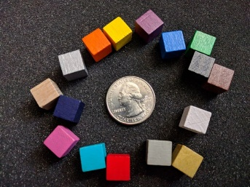In the game the digestate, thin and thick fraction cards can be replaced for cubes in three colors, which makes step two in the game, the digestate handling, easier to follow. These cubes will need to be ordered additional to the game. The three digestate cards in the game will be replaced by the following colors of cubes:

1. 60 Black cubes representing digestate
2. 30 Yellow cubes representing thin fraction
3. 30 Green cubes representing thick fraction

# Playing biomass cards

The playing cards can be placed in specific fields of the game (Figure 3 and 5), starting off with the biomass cards. The numbers coincide with the numbers in figure 5:

1. On the map (Figure 3 number 3) energy crops can be grown, harvest remains and domestic waste can be collected, and manure can be collected from dairy farms. Every card represents 25 hectares of required farmland and/or natural areas for harvest remains and in the case of domestic waste 25 hectares of village.
2. Energy crops, harvest remains, domestic waste, and manure can be imported from outside of the village (Figure 3 number 5) if space on the map is constricting. Imported cards have different scores for the roles.

For every biomass card a digestate card is produced that will need to be processed (Figure 3 and 5). The numbers coincide with the numbers in figure 5:

1. Digestate can be placed on the map (Figure 3 number 3) on agricultural land as fertilizer. Only one digestate card can be placed on the same piece of land and cannot be placed on natural areas or villages.
2. Digestate can also be exported to the surrounding region. Exported cards have other scores for the roles.
3. Digestate can be processed and upgraded into a thin and thick fraction which can be used as green fertilizer, thereby, replacing fossil fertilizer.
4. The Thin and Thick fraction can also be exported to the surrounding region. Exported cards have other scores for the roles.
5. A digestate card can be combined with a production card e.g. Manure energy crops or agricultural waste
6. Both green fertilizes cards (thin and Thick fraction) can be combined with a production card e.g. energy crops or agricultural waste and a digestate card on the map. A digestate card and a Thin fraction card can be combined with a manure card on the map.

* On a manure card on the map both a Digestate and a Thin fraction can be placed on the same card
* On an Energy crop or Harvest remains on the map both a Digestate and a Thick fraction can be placed on the same card
* A normal digestate card but cannot be placed on natural areas or villages.

|  |
| --- |
|  |
| *Figure 5: Placement of the playing cards on the map of the Adapner biogas game* |

# Playing the game

**PREPERATION:** Before starting the game, the game map (Appendix [1]) can be placed on a flat table large enough to handle A0 and the biomass cards (Appendix [2], cut out) can be placed on the game map [1] in the location indicated in Figure 3 number 2. Next 7 differently colored game pieces (Figure 8, preferably; white, black, yellow, blue, green, red, and grey) can be placed on start as all roles start with 0 points, to represent the different roles and follow their points received. (see [www.wegosustainable.nl/adapner-game](http://www.wegosustainable.nl/adapner-game) for game map and cards)

**STEP 1:** Give the presentation to explain the main workings of the game. When playing the game under correct guidance the rest will become clear. (see [www.wegosustainable.nl/adapner-game](http://www.wegosustainable.nl/adapner-game) for presentation)

**STEP 2:** The group of players will first divide the roles (Figure 2). It is possible for multiple players to use on role as long as all the roles are represented. When there are not enough players the roles of Energy and Nutrients can be omitted first as they are part of the common goal of the game.

**ROUND 1:** In the first round the goal is to make the village of Adapner energy neutral by producing 100 energy points using the different options for biomass. During this round biomass can be grown or collected on the map and/or imported (section 6 and figure 3).

**ROUND 2:** In this round the digestate produced by the AD system must be processed (Figure 6). For every used biomass card (locally produced and imported), a digestate card must be processed. Digestate can be returned to the field were biomass is collected, exported, upgraded, and/or even sold (section 6).

|  |
| --- |
|  |
| *Figure 6: Determining the amount of digestate cards produced in the Adapner biogas game* |

**ROUND 3:** In the final round the system can be optimized also with the addition of bonus cards (e.g. solar parks, wind turbines). This optimization must be discussed between the players as it can be different for every role. The question here is what is acceptable for the individual roles. Optimization can be achieved by changing biomass or digestate cards, including more import or export, upgrading digestate, or placing solar and wind.

|  |
| --- |
|  |
| *Figure 7: Bonus cards that can be used in the Adapner biogas game* |

# Printing and preparing the game

|  |
| --- |
| Amazon.com: Set of 10 Halma 25mm Pawn Peg Game Pieces Multicolor ... |
| *Figure 8: Game pieces* |

The game map (Appendix [1]) and playing cards (Appendix [2]) must be printed at minimal A1 and preferable in A0 format. Also, both must be printed in the same size as the playing cards are on scale with the map. When printed the game map [1] is ready for use and only requires 7 differently colored game pieces (Figure 8, preferably; white, black, yellow, blue, green, red, and grey) to represent the different roles and follow their points received. The playing cards [2] need to be cut out into individual cards.

Before starting the game, the game map [1] can be placed on a flat table large enough to handle A0 and the biomass cards [2] (cut out) can be placed on the game map [1] in the location indicated in Figure 3 number 2. The game pieces can be placed on start as all roles start with 0 points.

Additionally, when using the cubes instead of the digestate cards:

1. 60 Black cubes
2. 30 Yellow cubes
3. 30 Green cubes

**Appendix [1] The game map (Print in A0)**

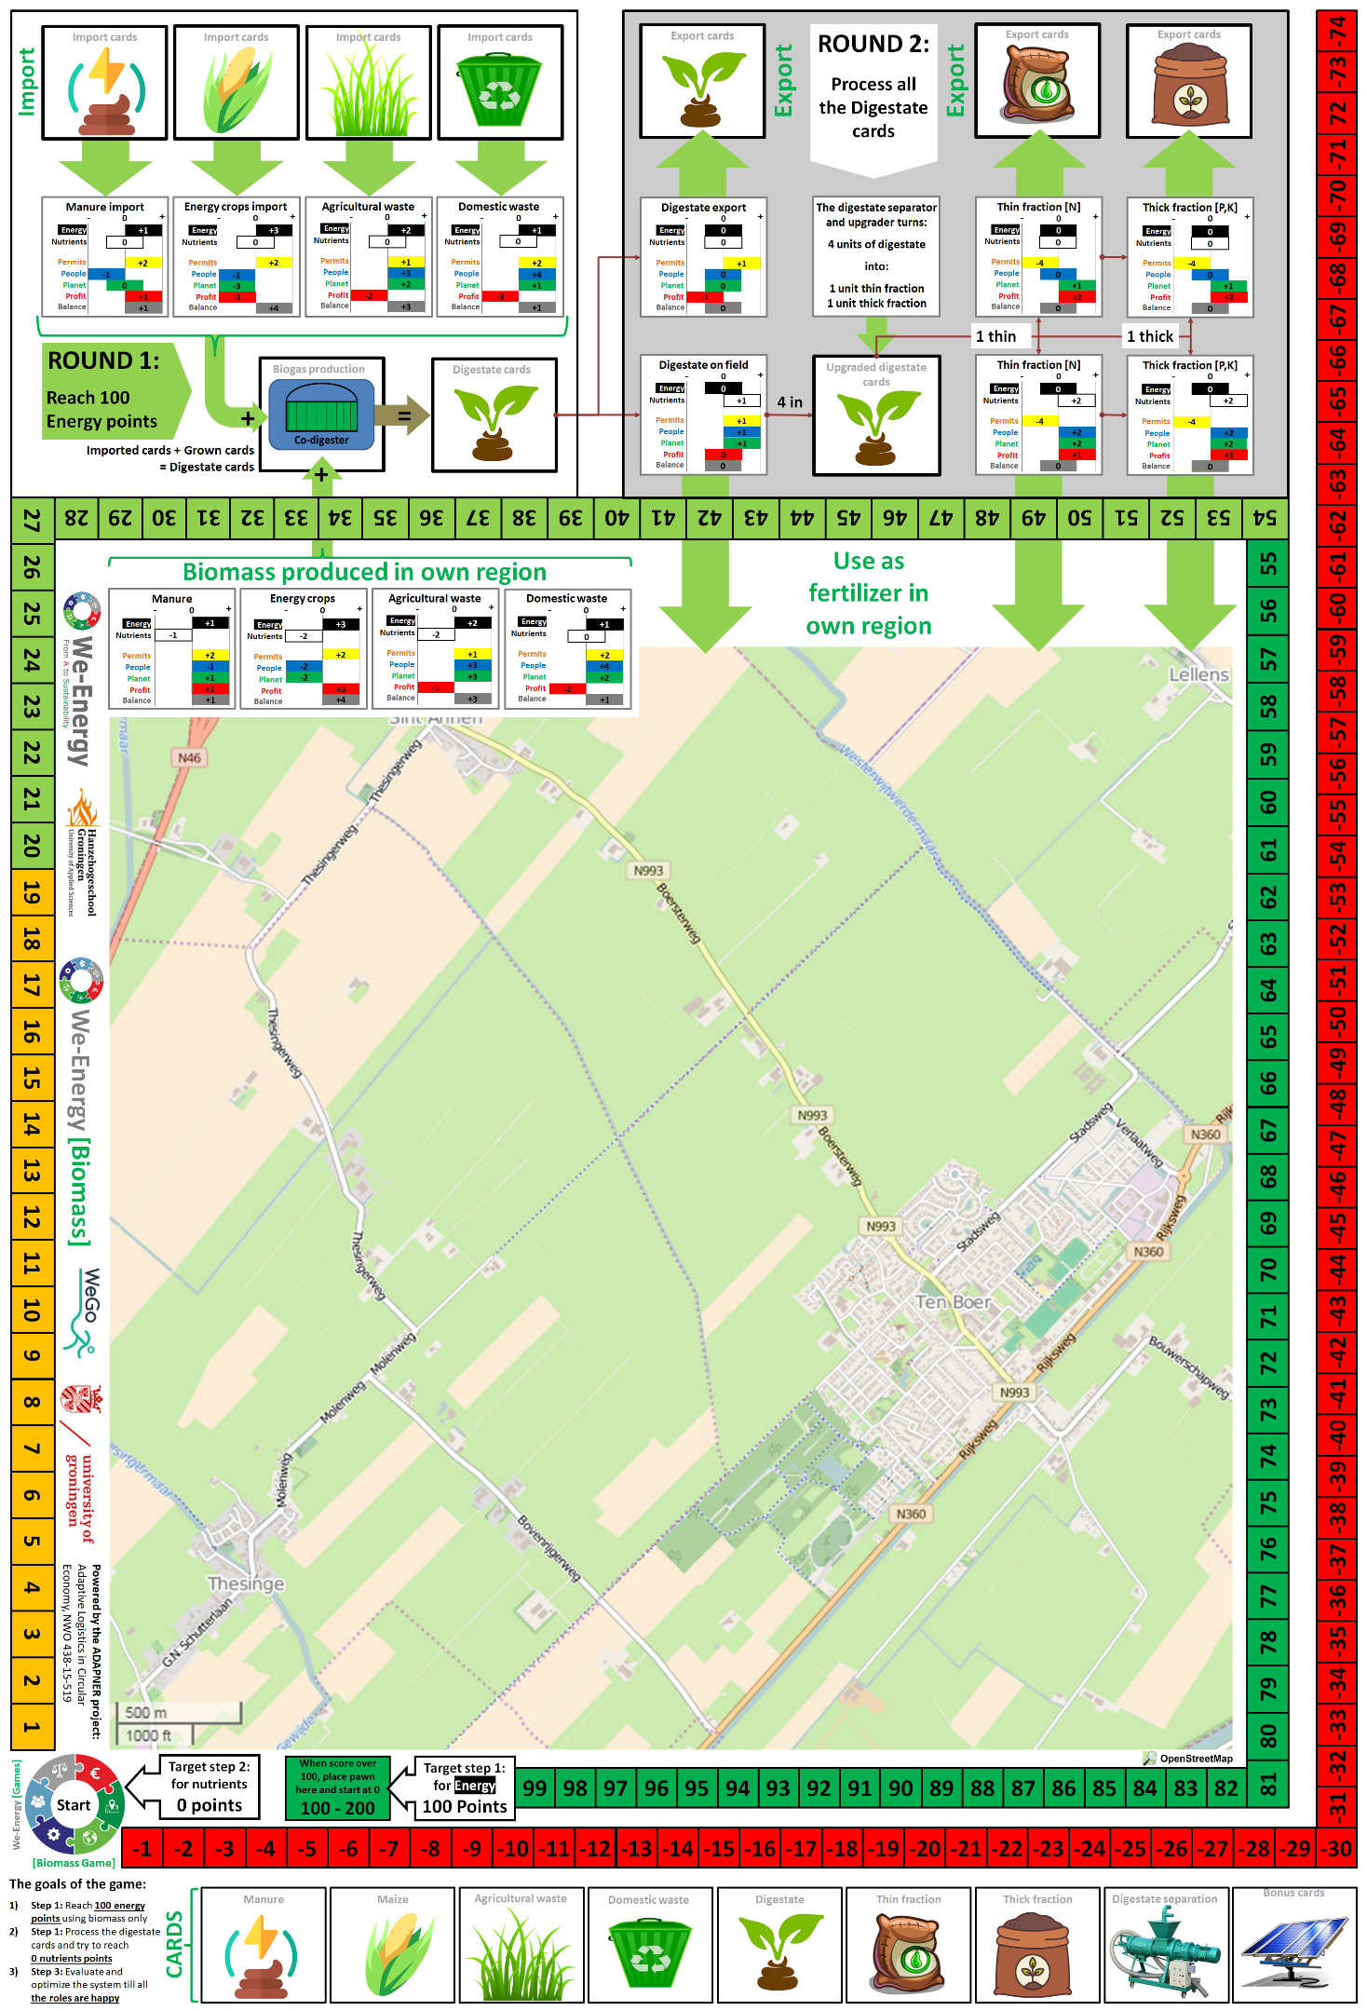

**Appendix [2] The playing cards (Print in A0 and cut out the playing cards)**

